Project 1: launched Windows instance using RDP and installed IIS web server using Powershell ISE.

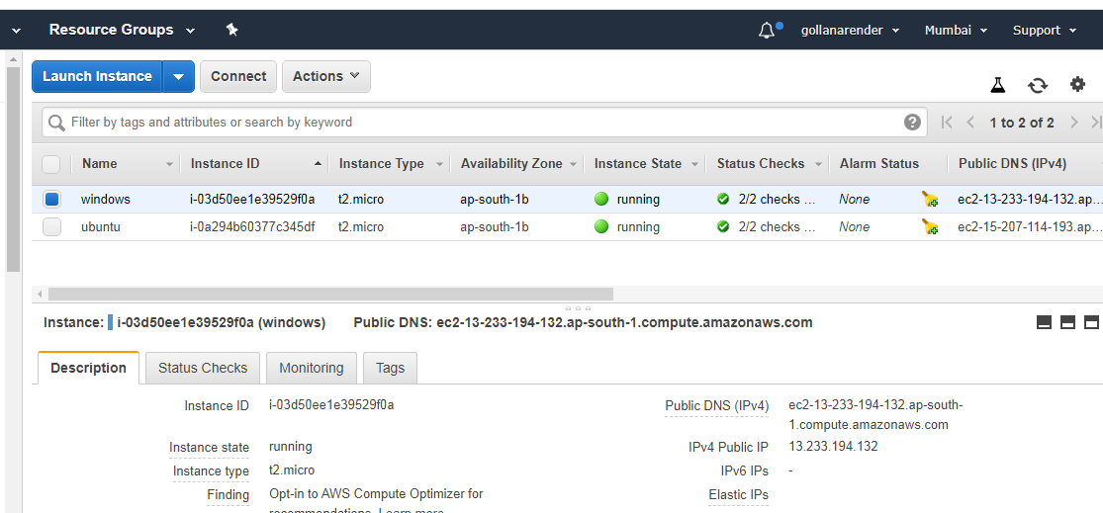

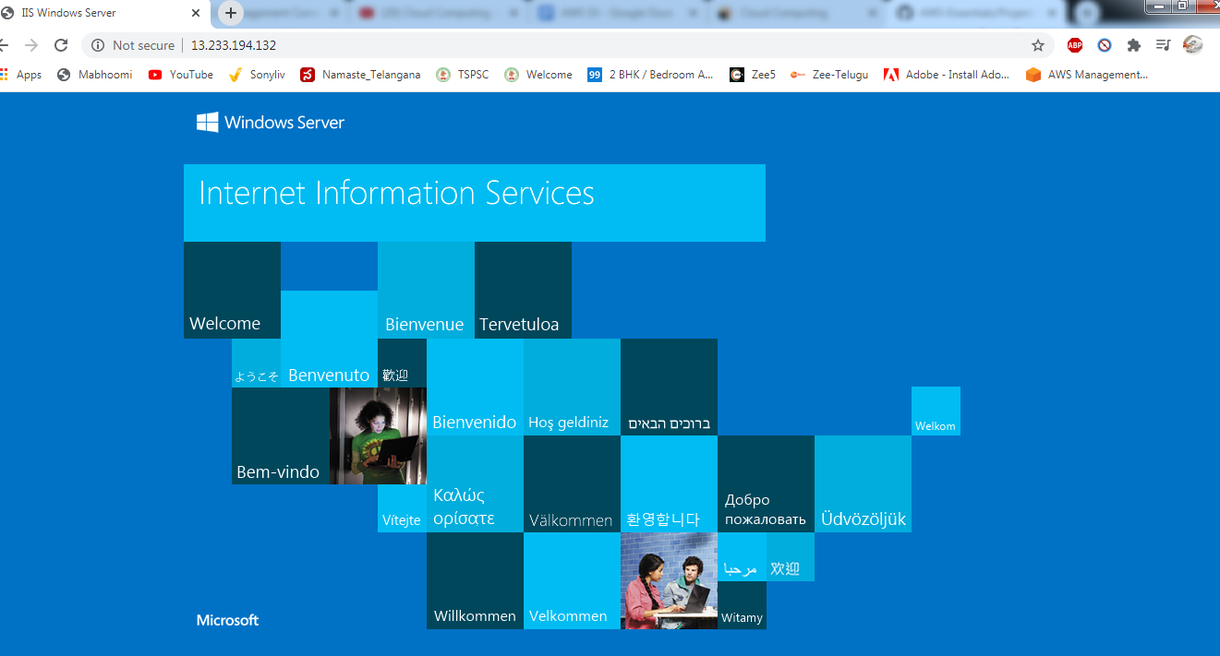

Project 2: Launched Ubuntu instance using SSH and installed nginx web server

